Instruction for running application ConsoleTestQV21.exe

1. Go to folder: **\ConsoleTestQV21\ConsoleTestQV21\bin\Debug**

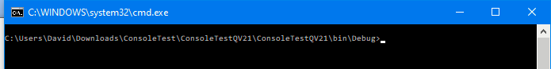

1. Enter **ConsoleTestQV21.exe**

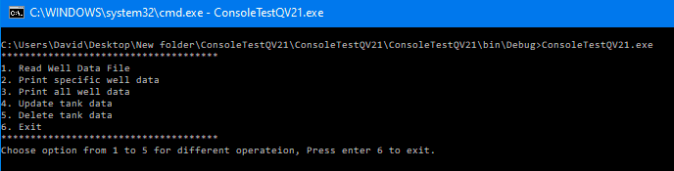

1. Enter 1 for **Read Well Data File**

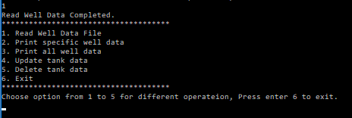

1. Enter 2 for **Print specific well data**

Type Tank MID: **1102**

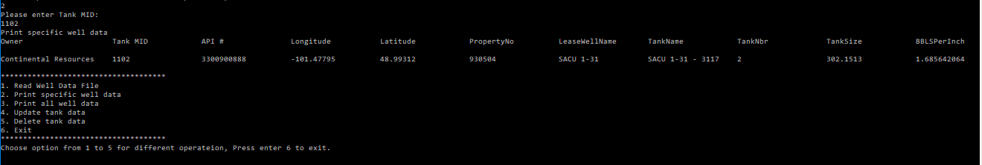

1. Enter 3 for **Print all well data**

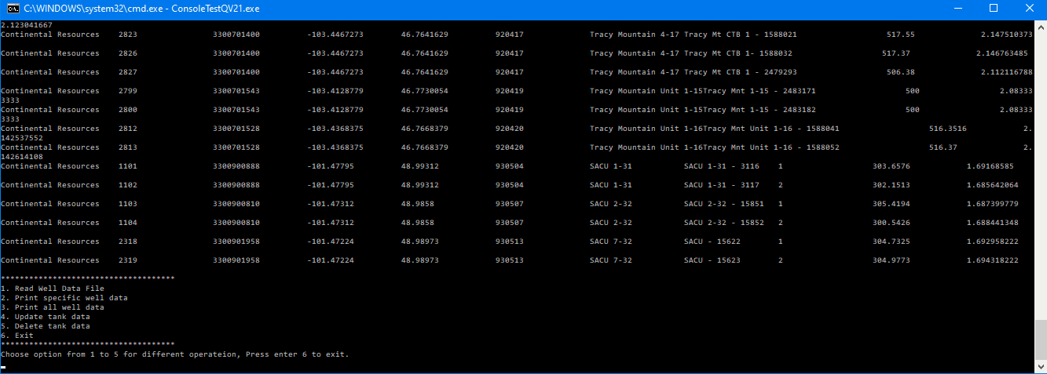

1. Enter 4 for **Update tank data**

Type Tank MID: **1102**

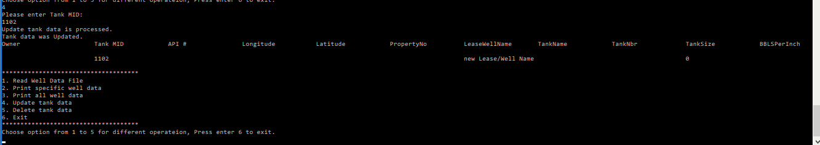

1. Enter 5 for **Delete tank data**

Type Tank MID: **1102**

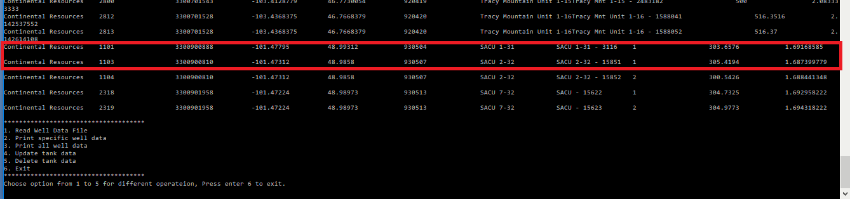

After running, we found that Tank data with Tank MID – **1102** was deleted from the list

1. Enter 6 for **Exit**

